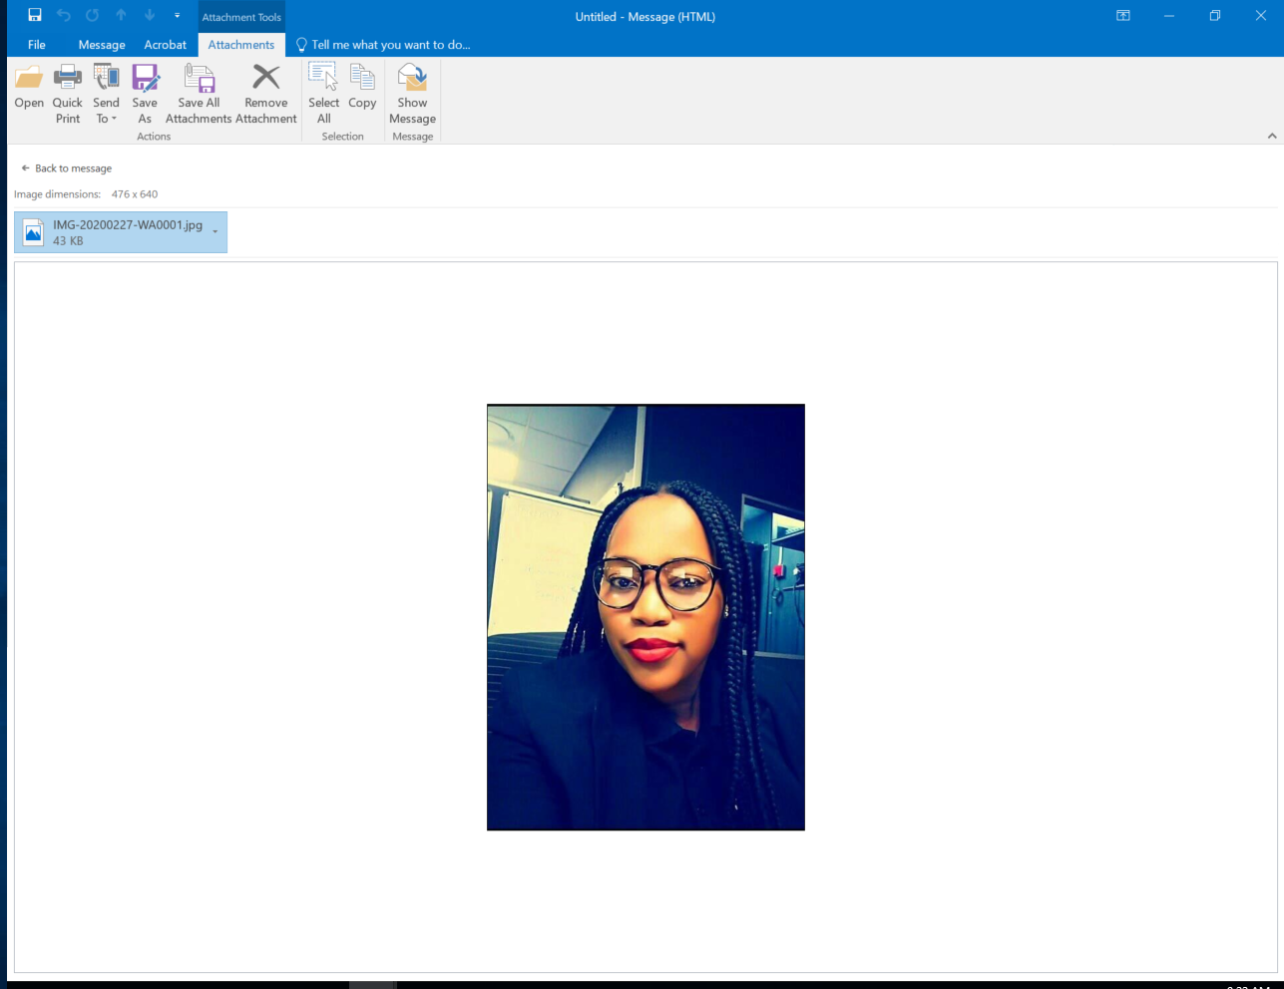
10153 Maboa Street.
Dobsonville Ext 3
Soweto 1684
South Africa
Nolukhanyo3@gmail.com
083 295 6355
NATIONALITY
Xhosa
DATE OF BIRTH
12 October 1986

SKILLS
Adaptability *****
Customer-Service *****
Effective Time Management *****
Communication Skills *****
Collaboration & Teamwork *****
Mobilizing for Optional Performance (organizational climate) *****
Skills@work | Business Writing *****
Skills@work | Personal Mastery

LANGUAGES
English *****
IsiZulu *****
Setswana*****
IsiXhosa*****

Details
Nolukhanyo Mgolodela
ADMIN ASSISTANT
Profile
Objective:
I enjoy work that provides intellectual stimulation. My ideal work environment is one that is very dynamic and which facilitates a culture of constant learning through experience and interaction with others. I am an ambitious and diligent worker who is willing to contribute and make the necessary sacrifices to achieve my goals as well as those of the organization that I am a part of.
Availability:
Current role requires a calendar month notice.
Key Competencies
Proficient or familiar with a vast array of competencies including:

- Analysing
- Deciding and Initiating Action
- Planning and Organizing
- Delivering Results and Meeting Customer Expectations
- Persuading and Influencing
- Relating and Networking
- Coping under Pressures and Setbacks
- Following Instructions and Procedures
- Working with People
- Adhering to Principles and Values
- Adapting and Responding Change

Employment History
Retail Assistant, Orlando Pirates Shop, Johannesburg
August 2023 to Current
- Execution of day to day store operations and focusing on product flow from the floor, to sales and stock room
- Maintaining an effective stockroom and logistical environment
- Administration of online orders, printing, packaging and courier to customers
- Recording and managing all inter-store and warehouse movement of stock
- Completing regular sales transactions involving cash, credit and cheques
- Alleviate shrinkage by securing stock
- Displaying of merchandise on the floor to appeal to consumers
- Maintaining general house-keeping of the shop
- Safekeeping of company assets
- Organising, maintaining and running pop-up mobile store during soccer games
- Processing online purchase orders

Admin Assistant, NA Glass and Aluminium, Johannesburg
September 2021 to Current
- Reception – Answering the Phone, taking messages, welcoming clients
- Filling
- General Office Administration
- Admin assistant to Office Manager
- Assisting Operations Staff with General Admin
- Dealing with Service Providers (Telkom)
- Ordering of Stationery and Consumables

Sales Reconnection and Reconciliation Agent, Fidelity ADT, Johannesburg
October 2020 – August 2021
- Cancellation for Moving Clients and Retentions
- Receive and process Moving Cancellations
- Qualify and Call all New Leads
- Attempt to book appointments for Relocation/Reconnection customers
- Schedule appointments in Sales Consultant Diaries
- Follow up on Unclosed Leads
- Handle calls from customers cancelling services
- Keep internal/external customers informed on the status of relocating process.
- Communicate and coordinate with internal departments and branches
- Record cancellations of appointments
- Book system removal where reconnections were not possible
- Analyse statistics relating to reconnections

Call Centre Agent, 7Arrows Security Group, Johannesburg
January 2012 – September 2020
- Receiving incoming calls
- Attending to walk in clients
- Resolving service related queries from phone-in clients
- Booking technical service calls
- Processing client cancellations
- Dealing and ensuring that client complaints are resolved
- Responding to customer queries on time
- Obtaining and evaluating all related information in order to handle inquiries and complaints
- Directing requests and unsolved issues to the designated resource
- Courtesy calls for installations
- Follow up calls after incidents such as break-ins and robberies etc.
- Ensure and provide quality service for internal/external customers
- Load sales leads to contact perspective clients
- Assisting the emergency control room with influx of alarm activations due to storm conditions
- Assisting clients to test their alarm system over the phone
- Assisting technicians to load radios and tag signals correctly
- Courtesy calls – installation, guarding and incidents

Customer Service Agent, ADT Security, Johannesburg
January 2005 – December 2011
- Provide basic technical assistance to clients
- Client and technical confirmation
- Record and distribution of sales leads
- Service call bookings
- Load radios
- Account queries
- Verification Listener information
- Delegation of queries/complaints to relevant parties
- Receive and action emergency calls

Education
Grade C, PSIRA, Johannesburg
January 2008 – March 2008
- Grade C Qualification

Matric, Malvern High School, Johannesburg
December 2000 – January 2004
Subject Passed:
- English
- Afrikaans
- Mathematics
- Physical Science
- Geography
- Accountancy

Diploma in PC Training, Boston City Campus, Johannesburg
January 2006 – December 2006
- Keyboarding
- Introduction to PC
- Windows XP
- Call Centre Operations
- Reception and Switchboard Skills
- MS Word
- MS Excel
- MS Outlook
- Business Writing
- Life Skills
- Principle Of Customer Services

References
Lucky Matshaba from Orlando Pirates
073 093 5009
Ruaan Miller from NA Glass and Aluminium
076 968 8027
Peter Motala from Fidelity ADT
| 072 123 2643
Susan De Beer from 7Arrows Security Group
082 891 2276
Polediso Damane from Fidelity ADT
Pdamane.za@fidelity-adt.co.za | 073 452 1686

